Context Model

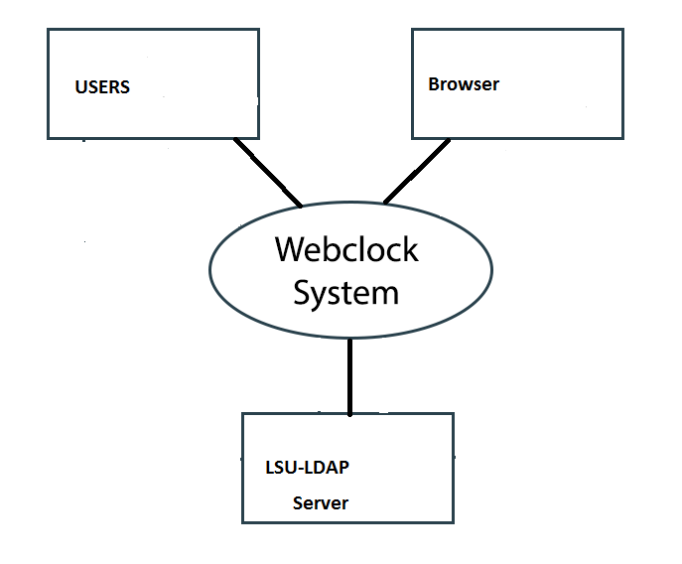

Finite State Machine

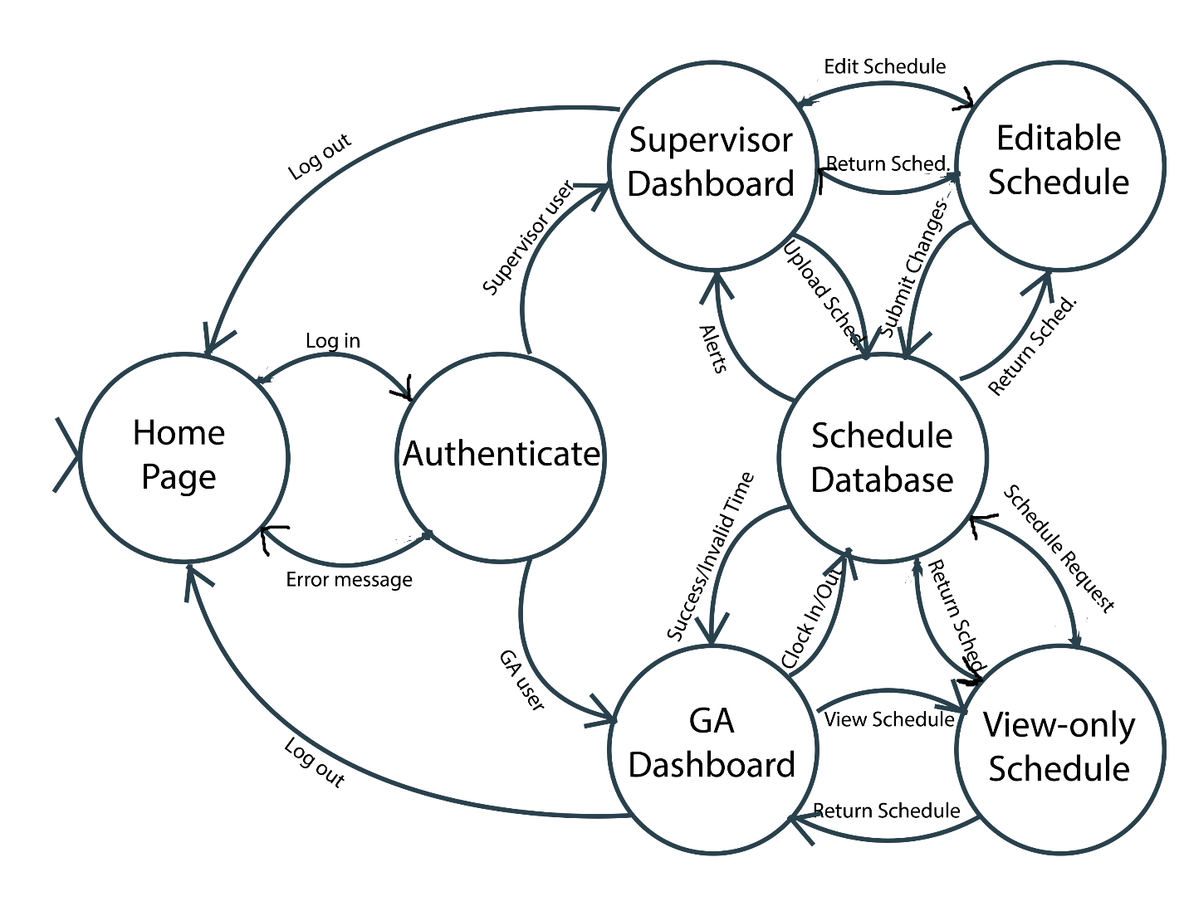

UML Diagram

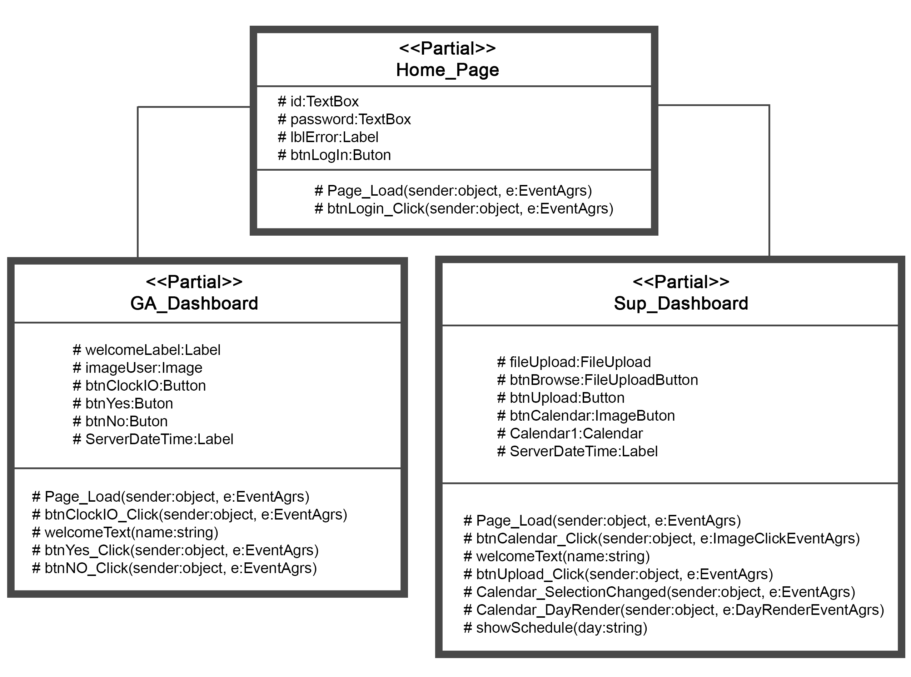

Case View Model

Views

**Development View**

The development view can show us, the developers, or help us in the planning and design of the system. Looking at coding structure and what dependencies the system may have. The configuration of deliverables and what constraints the system as a whole would have. For our system we could look at browsers and OS the system would run on.

**Logical View**

In this view we are looking at the functional requirements of the system. It shows the interactions of collaborating classes that are key in the system. This view ultimately shows us end-user functionality of the system. For instance, in our system the logical view would be in say the ability of the user to log meal times.

**Physical View**

This view addresses how the hardware and software are working together. In other words how the data is stored. This would be low level where logical is high level. For instance when we log a user into the system the log, user name and time, is saved to a location which can be referenced later.

**Process View**

This view is looking at the interactions of systems or interaction of processes. It is looking at the run-time behavior. For our system this would be the checking of known usernames with the inputted ones and also the associated password of the entered username.

Client-Sever Pattern

Client server would work well for this system since we have multiple people accessing a database over the network.

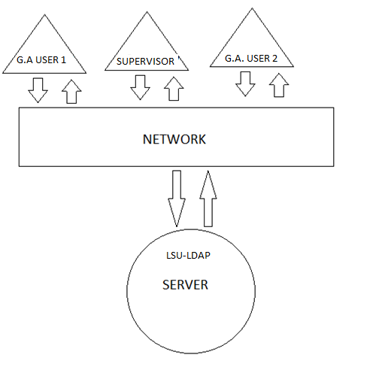

Each Client being a lab G.A. and they are accessing the LSU server to verify their credentials